Social Computing Assignment 2:

Aspect based Sentiment Classification from Reviews on Social Media Sites

# Student Details

Name: Utsav Basu  
Roll No.: 20CS30057

# Dataset Analysis

Train data count: 4840  
Test data count: 1211

## Objective 1

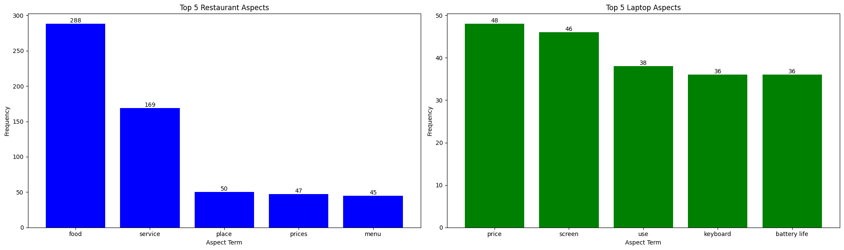

Figure : Aspect Term vs Frequency [for **Restaurant**]



Figure : Aspect Term vs Frequency [for **Laptop**]

## Objective 2

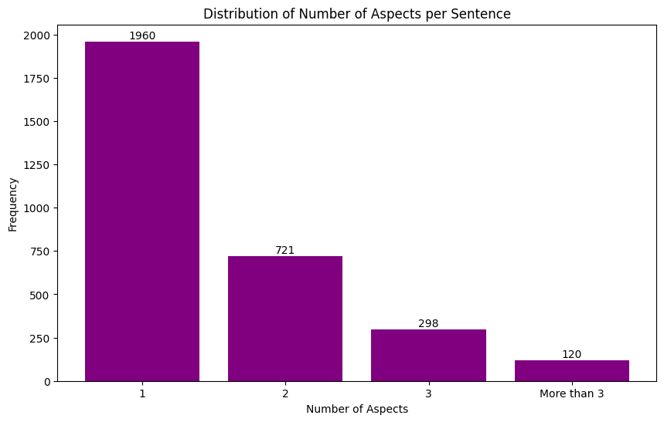

Figure : No. of aspects per Sentence vs Frequency

# Results and Analysis

## Part B (1)

### Evaluation Metrics:

|  |  |  |  |  |
| --- | --- | --- | --- | --- |
| **Label** | **Precision** | **Recall** | **F1-Score** | **Support** |
|  | | | | |
| **Conflict** | 0.33333 | 0.17647 | 0.23077 | 17 |
| **Negative** | 0.68935 | 0.68935 | 0.68935 | 338 |
| **Neutral** | 0.60119 | 0.44298 | 0.51010 | 228 |
| **Positive** | 0.77730 | 0.86146 | 0.81722 | 628 |
|  | | | | |
| **Accuracy** | 0.72502 | | | 1211 |
| **Macro Avg** | 0.60029 | 0.54257 | 0.56186 | 1211 |
| **Weighted Avg** | 0.71336 | 0.72502 | 0.71548 | 1211 |

### Confusion Matrix

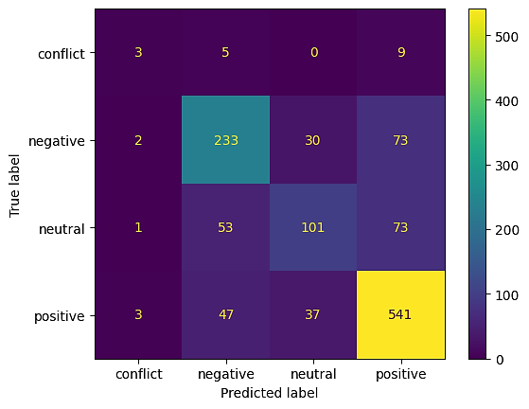

## Part B (2)

### Evaluation Metrics:

|  |  |  |  |  |
| --- | --- | --- | --- | --- |
| **Label** | **Precision** | **Recall** | **F1-Score** | **Support** |
|  | | | | |
| **Conflict** | 0.00000 | 0.00000 | 0.00000 | 17 |
| **Negative** | 0.65043 | 0.67160 | 0.66084 | 338 |
| **Neutral** | 0.57037 | 0.33772 | 0.42424 | 228 |
| **Positive** | 0.75928 | 0.87898 | 0.81476 | 628 |
|  | | | | |
| **Accuracy** | 0.70685 | | | 1211 |
| **Macro Avg** | 0.49502 | 0.47207 | 0.47496 | 1211 |
| **Weighted Avg** | 0.68268 | 0.70685 | 0.68684 | 1211 |

### Confusion Matrix

